horizontal line

**Zombieland CLI Team**

Cali, Colombia

Automatic Translations, Skillshare.

**May 14, 2020**

Internationalization has been a big part of our goals for this year, and we want to get closer to that objective by allowing users to see the video transcripts in their native language.

We already support transcript in English for all our Original classes, we are looking to implement a solution that would allow users to auto-translate these transcripts into the language of their choosing.

# Team Members

1. Carlos Andres Garcia, Front-end
2. Ivan Dario Lasso, Frontend - User Interface
3. Leonardo Calderon, Back-end

### **Role Description:**

* **Front-end** web development, also known as client-side development is the practice of producing HTML, CSS and JavaScript for a website or Web Application so that a user can see and interact with them directly. The challenge associated with front end development is that the tools and techniques used to create the front end of a website change constantly and so the developer needs to constantly be aware of how the field is developing
* **Back-end** Development refers to server-side development. It is the term used for the behind-the-scenes activities that happen when performing any action on a website. It can be logging in to your account or purchasing a watch from an online store. Backend developer focuses on databases, scripting, and the architecture of websites. Code written by back-end developers helps to communicate the database information to the browser.
* **The user interface (UI)** is the point of human-computer interaction and communication in a device. This can include display screens, keyboards, a mouse and the appearance of a desktop. It is also the way through which a user interacts with an application or a website. The growing dependence of many businesses on web applications and mobile applications has led many companies to place increased priority on UI in an effort to improve the user's overall experience.

*Roles decided based on experience and personal preferences. It can change according to the requirements.*

# Technologies

Main technologies proposed by the client, alternatives proposed by the CLI team.

1. **GraphQL**

GraphQL is a query language for APIs and a runtime for fulfilling those queries with your existing data. GraphQL provides a complete and understandable description of the data in your API, gives clients the power to ask for exactly what they need and nothing more, makes it easier to evolve APIs over time, and enables powerful developer tools.

<https://graphql.org/>

1. **Javascript options to evaluate:**

JavaScript (JS) is a lightweight, interpreted, or just-in-time compiled programming language with first-class functions. While it is most well-known as the scripting language for Web pages, many non-browser environments also use it, such as Node.js, Apache CouchDB and Adobe Acrobat. JavaScript is a prototype-based, multi-paradigm, single-threaded, dynamic language, supporting object-oriented, imperative, and declarative (e.g. functional programming) styles.

* 1. Typescript: <https://www.typescriptlang.org/>
  2. React.js : <https://reactjs.org/>
  3. Next.js: <https://nextjs.org/>

1. **Translation Services options to evaluate:**

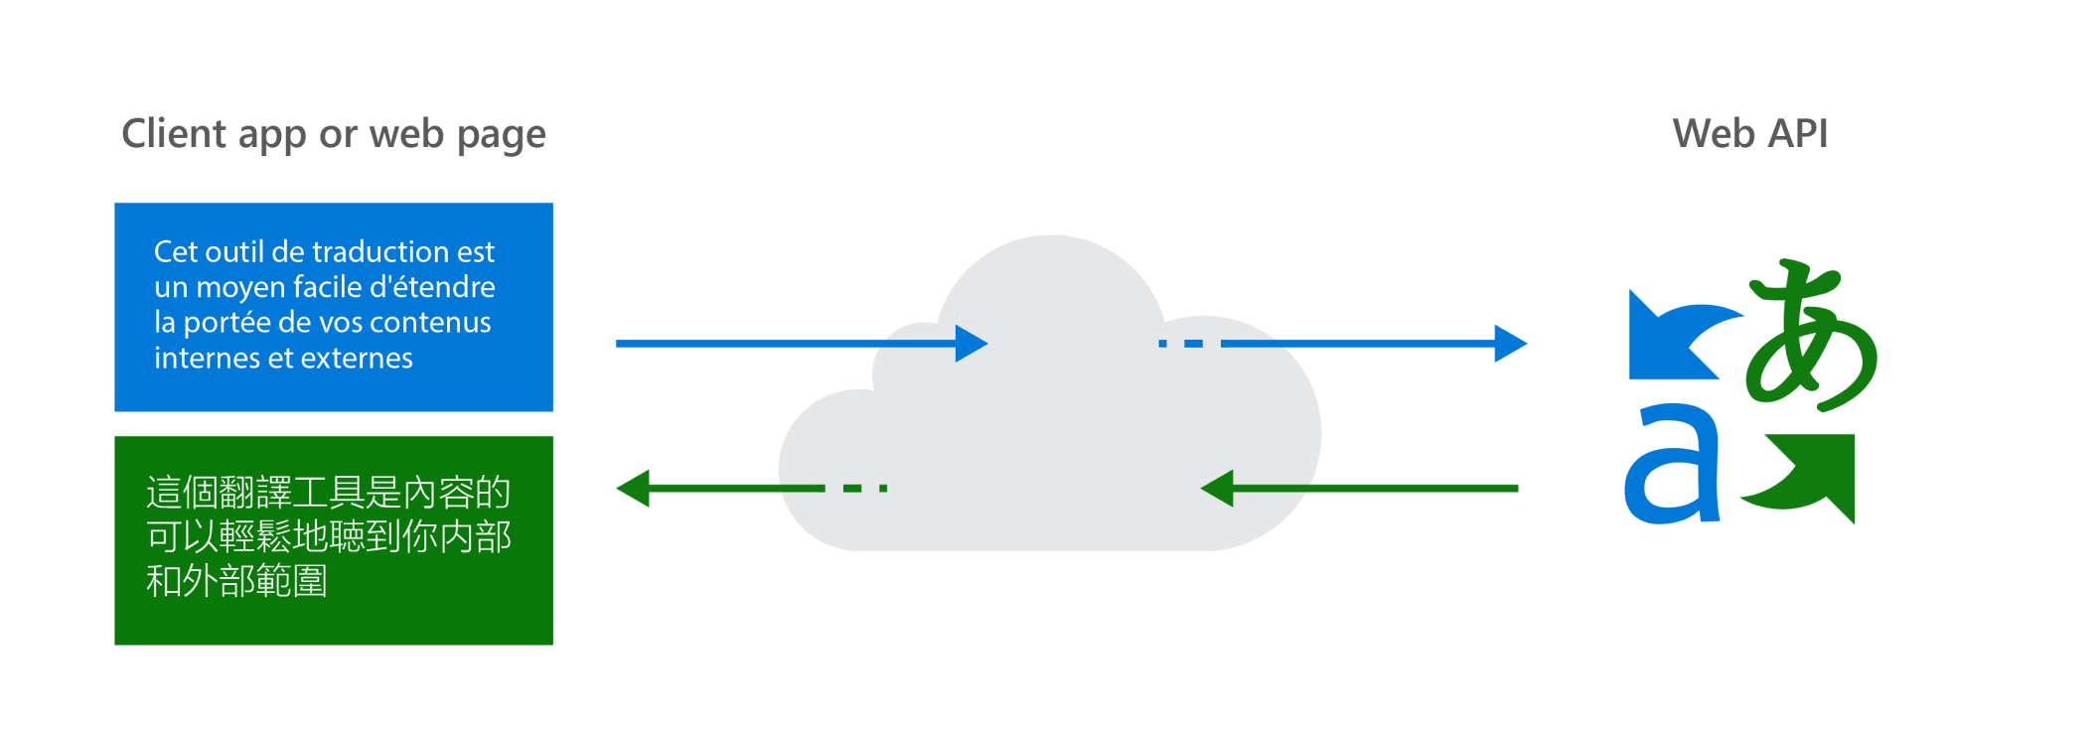

1. AWS Translate:<https://aws.amazon.com/translate/>

Amazon Translate is a text translation service that uses advanced machine learning technologies to provide high-quality translation on demand. You can use Amazon Translate to translate unstructured text documents or to build applications that work in multiple languages.

1. Microsoft Translate: https://azure.microsoft.com/en-us/services/cognitive-services/translator/

Translator is a cloud-based machine translation service you can use to translate text in near real-time through a simple REST API call. The service uses modern neural machine translation technology and offers statistical machine translation technology. Custom Translator is an extension of Translator, which allows you to build neural translation systems. The customized translation system can be used to translate text with Translator or Microsoft Speech Services.

1. If there’s a need to develop a training model, we can use Python.

# 

# Challenge

## Scope

The feature can display the transcription translated in English with the time of each track. Similar to the following picture:

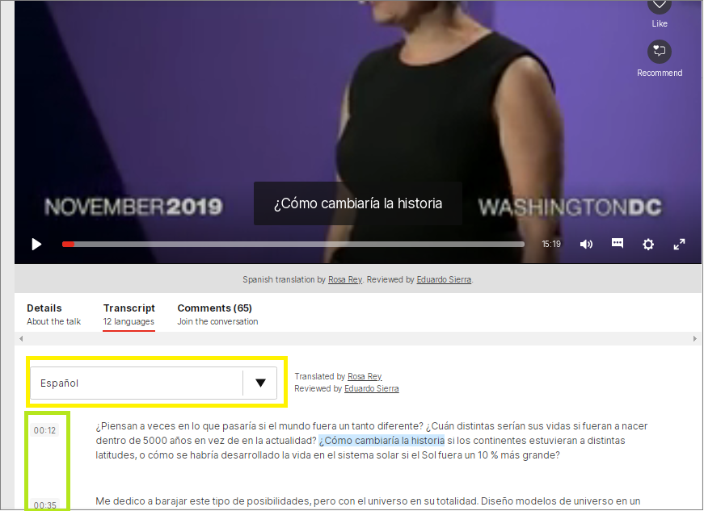

The audio originates from this video is in the English language, which was transcribed for subtitles. These subtitles in turn are translated, in this case into the Spanish language.

Take a close look at the text highlighted in light blue “**¿Cómo cambiaría la historia**”. This corresponds to the subtitle that is displayed at this time in the video and in turn corresponds to a period of time in which the speaker is saying that phrase.

The language in which the translation is being made is indicated in the box marked in yellow.

The green box indicates the time in the video where the paragraph begins.

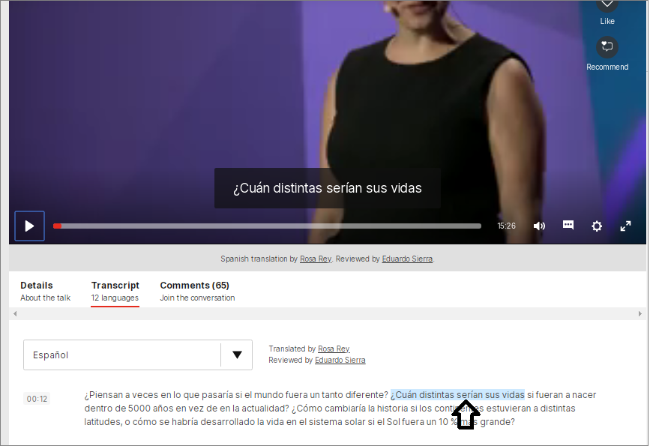

If the user clicks any part of the text as shown in the previous image, the video will automatically be located in that place within the video track displaying the beginning of the phrase.

And finally the user can change language:

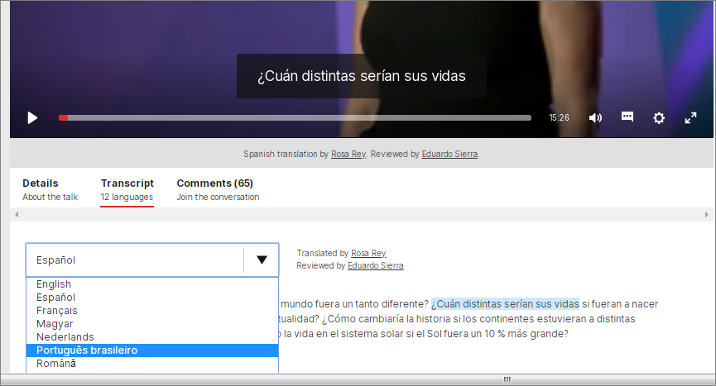

As can be seen, the subtitles are translated into the selected language.

## Problem to solve

## Give the user a new feature to be able to see the transcription translated into a preferred language, by default it will be in English.

## The project will not solve

In this scope:

* The translations were only displayed at the bottom and not within the video.
* The transcribed and translated text will only be displayed but it will not have the functionality to mark a phrase and that the video will automatically locate the exact place.
* There will only be translations from two languages.
* Translations will not be subtitled within the video.

## Project will help

Give to the User a new option to review the video content using text transcripcion, and with the possibility to change the text language

# **Risks**

## Project Management Risk

* Bad definition of the MVP
* Inappropriate use of technologies due to lack of time.
* Poor distribution of work and roles.
* Inappropriate design
* Do not consider important test cases

## Technical risks

* Poor performance times
* Inefficient user interface
* Low agility in the management of technologies

# 

# 

# 

# Infrastructure

The initial plan will be to create a Github Repository where we manage each project’s progress, for this purpose each person on the team will have their own branch, which will be exclusive to manage development and testing of the project.

Changes must go through a pull request which must be reviewed by each team person to allow their integration into the repository master, we will use some directives that allow regulating and managing merges.

* **Repositories:**
  + Skillshare_TT_Frontend
  + Skillshare_TT_Backend
  + Skillshare_TT_Integration
* **General branches of the repositories**
  + master (Production)
  + dev(integration / Test)
* **Strategy for deployment**
  + Alpha test inside the CLI Team
  + Betha test with the client
  + Final test with the whole Team
* **Describe how you will populate your app with data**
  + No data will be populated. Test images will be used to test this new feature in Skillshare platform
* **Describe what tools, automation or process you will use for testing**
  + Unittest

# 

# 

# 

# 

# Existing Solutions

It is a requirement requested by the client. Custom development.

Take this TED class as an example: <https://www.ted.com/talks/risa_wechsler_the_search_for_dark_matter_and_what_we_ve_found_so_far/transcript#t-27649>

As you can see, in addition to subtitles, TED allows users to pick a language for the transcripts. You can also click on a certain portion of the transcripts and the video player will jump into the specific part of the video that plays the text you clicked on.

In addition, Transcripts and Subtitles don’t replace each other, they serve as complements. For the scope of this task, we are focusing solely on the transcripts, but if time allows, we’d like to evaluate solutions for multilingual subtitles as well.

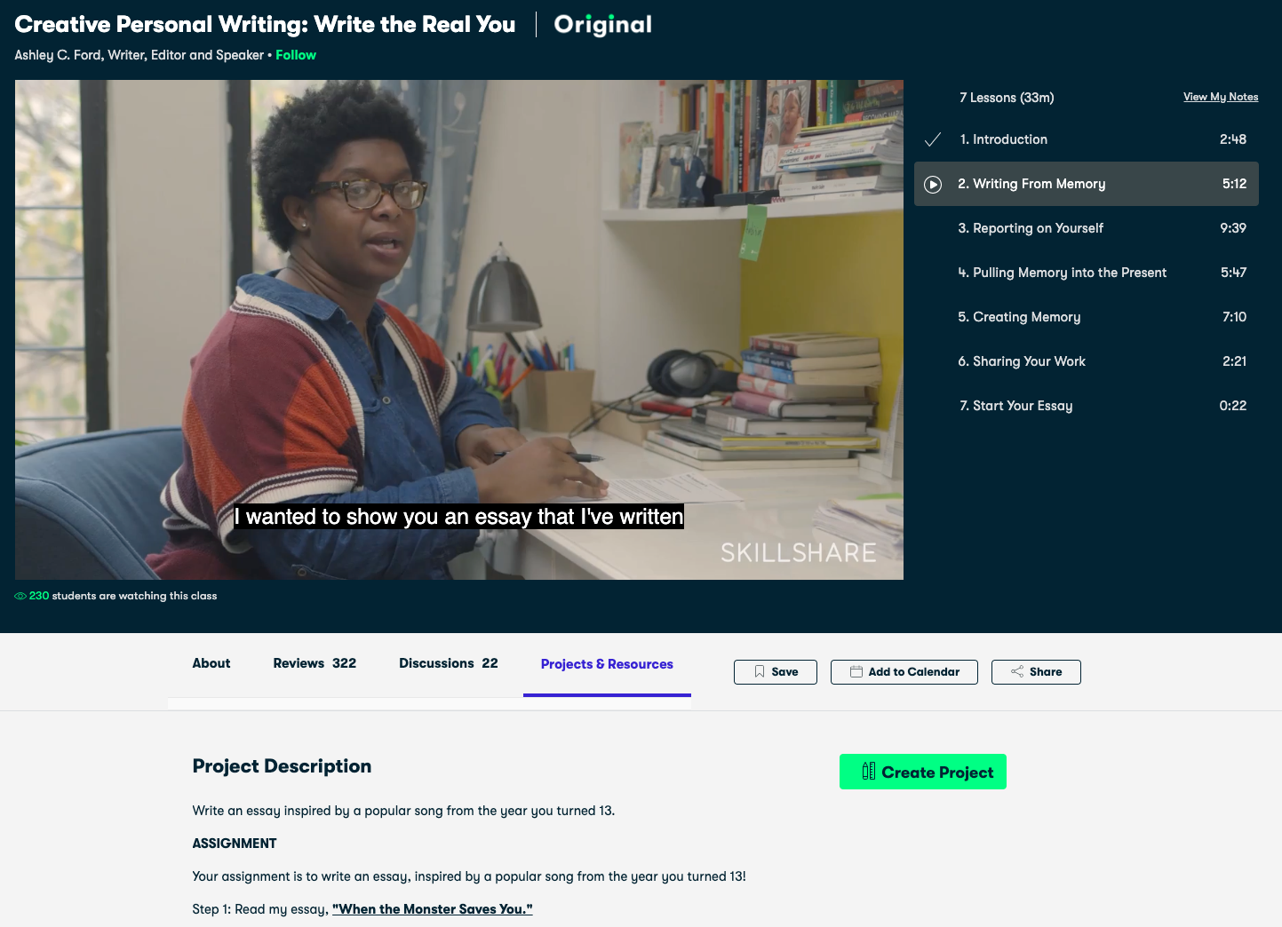

**Prepared by Carlos Garcia, Leonardo Calderon and Ivan Lasso.**

**14-may-2020.**

**Edited 20-may-2020**